**B. V. V. Sangha’s**

**BASAVESHWAR ENGINEERING COLLEGE (Autonomous)**

**BAGALKOT**



**2017-2018**

**PROJECT SYNOPSIS ON**

**KRISHI MITRA (FARMingBOT)**

**TEAM MEMBERS NAME: USN:**

VISHAL SARIKDAR 2BA14ME128

RUTWIK PATIL 2BA15EC065

SURESH KENGALGUTTI 2BA16EC434

**GUIDE NAME:** Dr. B.G. SHIPPERMATTI

**DATE:**

**CONTENTS**

* **Abstract**
* **Introduction**
* **Block diagram**
* **Details of the Block**
* **Program Code**
* **Application**
* **Advantages**
* **Disadvantages**
* **Conclusion**
* **References**

**Abstract:**

**Agricultural robots** are a robot deployed for agricultural purposes. Emerging applications of robots or drones in agriculture include weed control, cloud seeding, planting seeds, harvesting, environmental monitoring and soil analysis.

Agriculture has always been the backbone of India for a long time. The project we put forth has been designed to automate the work of a farmer in Nursery so that he can tirelessly perform his farming tasks. We intend to automate the most common and frequent tasks of the farmer.

Our team aims at building a robot that can perform almost all processes prior to harvesting including digging, sowing, pesticide application and watering.

This is achieved by an electro-mechanical system that can be programmed to do the tasks.

**Introduction:**

**Agricultural robots** are a  robot  deployed for  agricultural  purposes . Emerging applications of robots or drones in agriculture include weed control, cloud seeding, planting seeds, harvesting, environmental monitoring  and soil analysis.

Agriculture has always been the backbone of India for a long time. The project we put forth has been designed to automate the work of a farmer in Nursery so that he can tirelessly perform his farming tasks. We intend to automate the most common and frequent tasks of the farmer.

Our team aims at building a robot that can perform almost all processes prior to harvesting including digging, sowing, pesticide application and watering.

This is achieved by an electro-mechanical system that can be programmed to do the tasks.

**Block diagram**

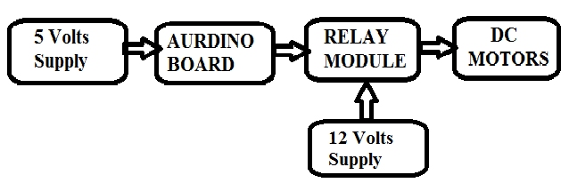

Details of the Block

**1. 5 Volt Supply:**

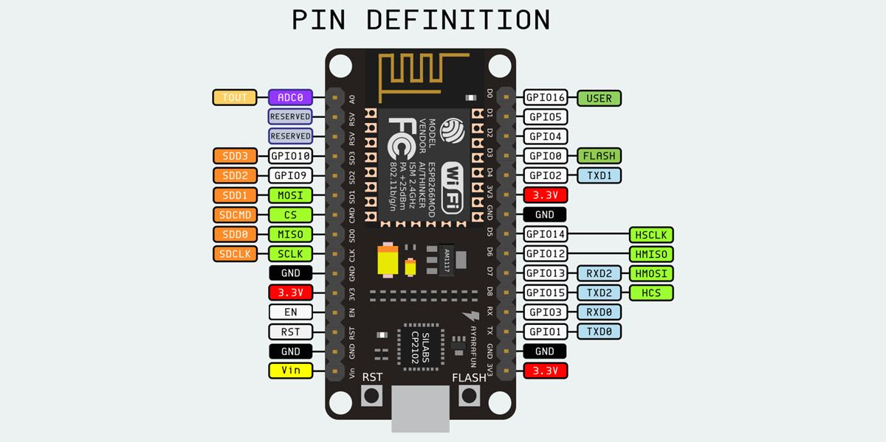

Introduction to the Arduino Board Looking at the board from the top down, this is an outline of what you will see (parts of the board you might interact with in the course of normal use are highlighted)

Starting clockwise from the top center:

-Analog Reference pin (orange)

-Digital Ground (light green)

-Digital Pins 2-13 (green)

-Digital Pins 0-1/Serial In/Out - TX/RX (dark green) - These pins cannot be used for digital i/o (digitalRead and digitalWrite) if you are also using serial communication (e.g. Serial.begin).

-Reset Button - S1 (dark blue)

-In-circuit Serial Programmer (blue-green)

-Analog In Pins 0-5 (light blue)

-Power and Ground Pins (power: orange, grounds: light orange)

-External Power Supply In (9-12VDC) - X1 (pink)

-Toggles External Power and USB Power (place jumper on two pins closest to desired supply) - SV1 (purple)

-USB (used for uploading sketches to the board and for serial communication between the board and the computer; can be used to power the board) (yellow)

**DIGITAL PINS**

In addition to the specific functions listed below, the digital pins on an Arduino board can be used for general purpose input and output via the pinMode(), digitalRead(), and digitalWrite() commands. Each pin has an internal pull-up resistor which can be turned on and off using digitalWrite() (w/ a value of HIGH or LOW, respectively) when the pin is configured as an input. The maximum current per pin is 40 mA.

-Serial: 0 (RX) and 1 (TX). Used to receive (RX) and transmit (TX) TTL serial data. On the Arduino Diecimila, these pins are connected to the corresponding pins of the FTDI USB-to-TTL Serial chip. On the Arduino BT, they are connected to the corresponding pins of the WT11 Bluetooth module. On the Arduino Mini and LilyPad Arduino, they are intended for use with an external TTL serial module (e.g. the Mini-USB Adapter).

-External Interrupts: 2 and 3. These pins can be configured to trigger an interrupt on a low value, a rising or falling edge, or a change in value. See the attachInterrupt() function for details.

-PWM: 3, 5, 6, 9, 10, and 11. Provide 8-bit PWM output with the analogWrite() function. On boards with an ATmega8, PWM output is available only on pins 9, 10, and 11.

-BT Reset: 7. (Arduino BT-only) Connected to the reset line of the bluetooth module.

-SPI: 10 (SS), 11 (MOSI), 12 (MISO), 13 (SCK). These pins support SPI communication, which, although provided by the underlying hardware, is not currently included in the Arduino language.

-LED: 13. On the Diecimila and LilyPad, there is a built-in LED connected to digital pin 13. When the pin is HIGH value, the LED is on, when the pin is LOW, it's off.

Analog Pins

In addition to the specific functions listed below, the analog input pins support 10-bit analog-to-digital conversion (ADC) using the analogRead() function. Most of the analog inputs can also be used as digital pins: analog input 0 as digital pin 14 through analog input 5 as digital pin 19. Analog inputs 6 and 7 (present on the Mini and BT) cannot be used as digital pins.

-I2C: 4 (SDA) and 5 (SCL). Support I2C (TWI) communication using the Wire library (documentation on the Wiring website).

•Small board analog output AO and AD module connected through the AD converter, you can get more precise values ​​of soil moisture;

Programme Code

#define A 5 //wheels clock wise D1

#define B 4//wheels anti clock wise D2

#define C 0//seeder D3

#define D 2//slider clock wise D4

#define E 14//slider anti clock wise D5

#define F 12//injecting D6

#define G 13//WATERING

void setup(){

pin Mode(A,OUTPUT);

pin Mode(B,OUTPUT);

pin Mode(C,OUTPUT);

pin Mode(D,OUTPUT);

pin Mode(E,OUTPUT);

pin Mode(F,OUTPUT);

pin Mode(G,OUTPUT);

}

void loop(){

for(int k=0;k<3;k++)

{

for(int i=0;i<3;i++)

{

digital Write(A,HIGH);

digital Write(C,LOW);

delay(1000);

digital Write(A,LOW);

digital Write(F,HIGH);

delay(1000);

digital Write(F,LOW);

digital Write(C,HIGH);

digital Write(G,HIGH);

delay(500);

digital Write(G,LOW);

delay(3000);

}

{

digital Write(C,LOW);

digital Write(D,HIGH);

delay(5500);

digital Write(D,LOW);

digital Write(C,HIGH);

digital Write(G,HIGH);

delay(500);

digital Write(G,LOW);

delay(500);

}

for(int j=0;j<3;j++)

{

digital Write(B,HIGH);

digital Write(C,LOW);

delay(1000);

digital Write(B,LOW);

digital Write(F,HIGH);

delay(1000);

digital Write(F,LOW);

digital Write(C,HIGH);

digital Write(G,HIGH);

delay(500);

digital Write(G,LOW);

delay(500);

delay(3000);

}

digital Write(C,LOW);

digital Write(D,HIGH);

delay(5500);

digital Write(C,HIGH);

digital Write(D,LOW);

digital Write(G,HIGH);

delay(500);

digital Write(G,LOW);

delay(500);

}

int i, j, k=0;

for(int k=0;k<3;k++)

{

for(int i=0;i<3;i++)

{

digital Write(A,HIGH);

digital Write(C,LOW);

delay(1000);

digital Write(A,LOW);

digital Write(F,HIGH);

delay(1000);

digital Write(F,LOW);

digital Write(C,HIGH);

digital Write(G,HIGH);

delay(500);

digital Write(G,LOW);

delay(500);

delay(3000);

}

{

digital Write(C,LOW);

digital Write(E,HIGH);

delay(5500);

digital Write(E,LOW);

digital Write(C,HIGH);

digital Write(G,HIGH);

delay(500);

digital Write(G,LOW);

delay(500);

}

for(int j=0;j<3;j++)

{

digital Write(B,HIGH);

digital Write(C,LOW);

delay(1000);

digital Write(B,LOW);

digital Write(F,HIGH);

delay(1000);

digital Write(F,LOW);

digital Write(C,HIGH);

digital Write(G,HIGH);

delay(500);

digital Write(G,LOW);

delay(3000);

}

digital Write(C,LOW);

digital Write(E,HIGH);

delay(5500);

digital Write(C,HIGH);

digital Write(G,HIGH);

delay(500);

digital Write(G,HIGH);

delay(500);

digital Write(E,LOW);

}

}

**Application:**

* Sowing, watering and pesticide/weedicide application process is automated.
* Crop growing process is made efficient for medium/large nurseries.
* It is useful at time of low availability of labor.
* Possibility to improve the machine without significant design changes.
* It reduces the time of farmer so he can do other tasks at hand.

**Advantages:**

* It is use to save power
* It is use to save a time
* It can be built in less cost
* We maintained large area in forming field

Disadvantages

* Initial investment is high.
* Not entirely farmer independent.

Conclusion

This project is to consume less electrical energy and water to helpful in the agricultural field and by making cloud computing inform the former whatever things are happen in the field by using sensors we are going to find the moisture level of the soil and control the over follow of water in the field and to save the time of former we are providing a automatic control of the motor by the cloud computing And we are sending moisture level values to know the variations of the moisture content by using the moisture we provides a automatic control of motor to without damage the crops

References

1. [www.arduinouno.com](http://www.arduinouno.com)
2. [www.busboard.com](http://www.busboard.com)
3. [www.arduino.cc/en/main/arduinoboardmega2560](http://www.arduino.cc/en/main/arduinoboardmega2560)

.

Top of Form

Bottom of Form